DOCKER ASSISMENT NO 5 SCREENTSHOTS……….
A. Project Setup
- Project Folder Structure
- 📸 Screenshot: Folder structure in Explorer.
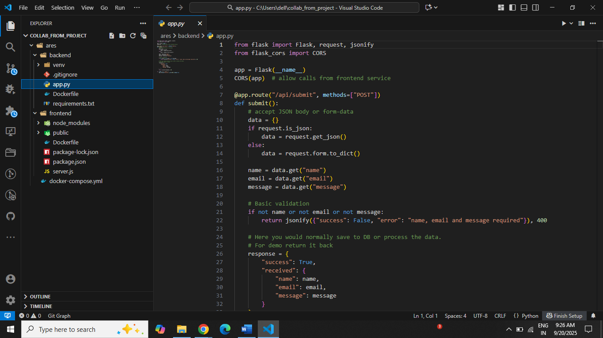

B. Docker Builds
- Build Backend Image
  - Run:
  - docker build -t harsh630/collab-backend:latest ./backend
  - 📸 Screenshot: The successful build output showing Successfully tagged harsh630/collab-backend:latest.
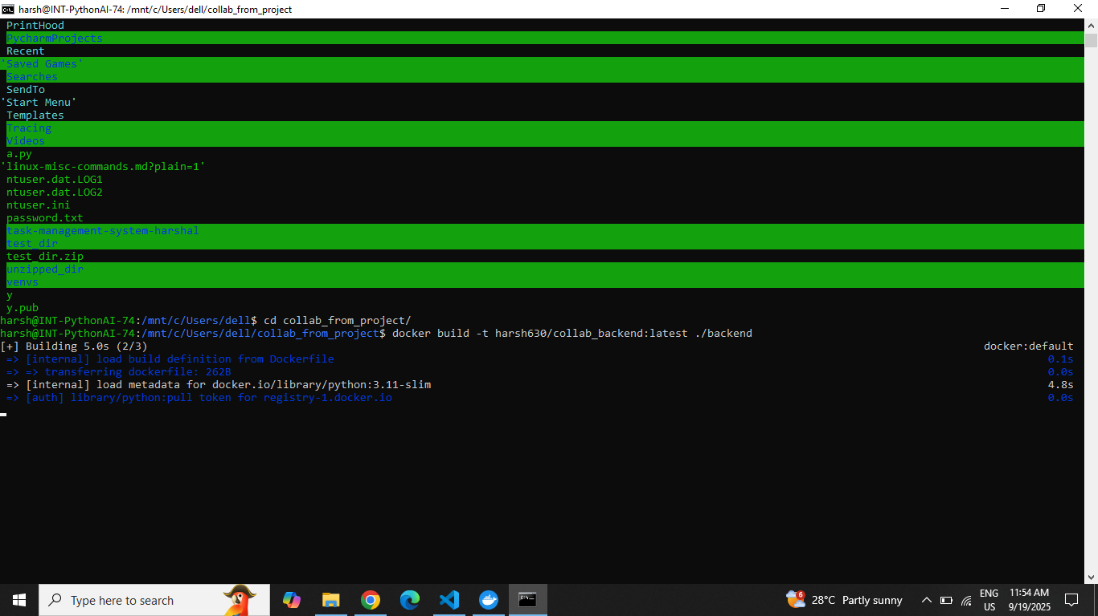

Build Frontend Image
- Run:
- docker build -t harsh630/collab-frontend:latest ./frontend
- 📸 Screenshot: The successful build output for frontend.
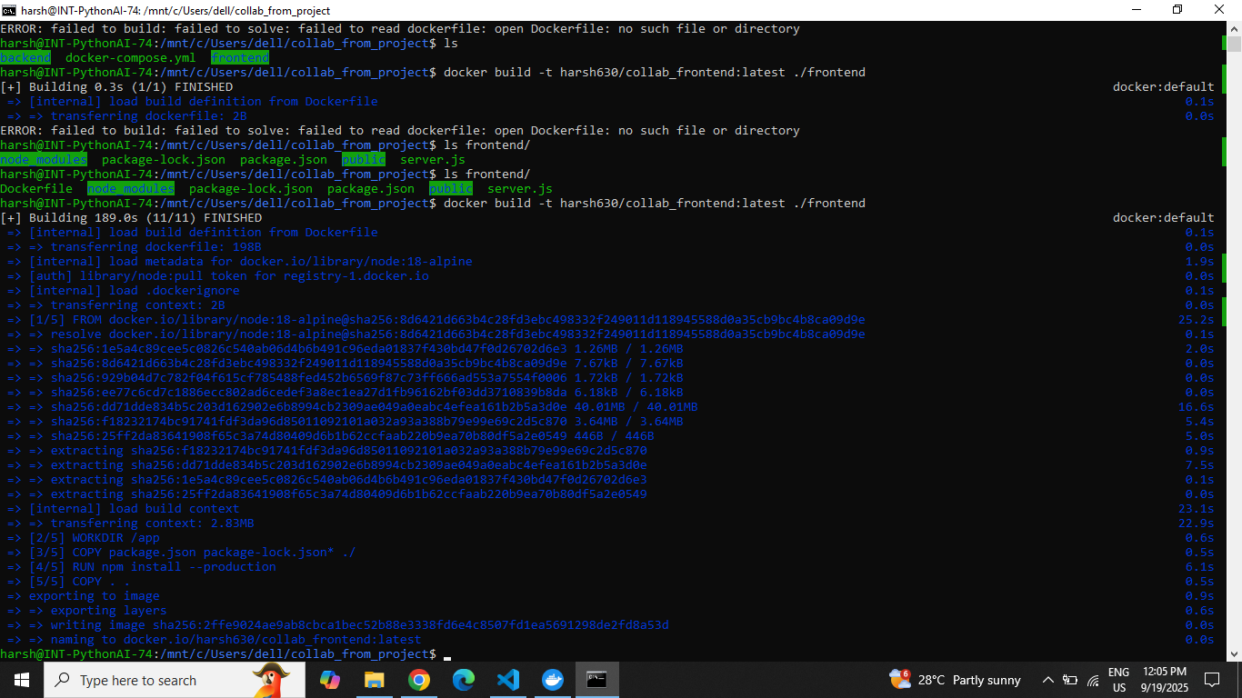

C. Docker Hub Push
- Push Backend Image
  - Run:
  - docker push harsh630/collab-backend:latest
  - 📸 Screenshot: Terminal output showing upload progress/completion on Docker Hub.
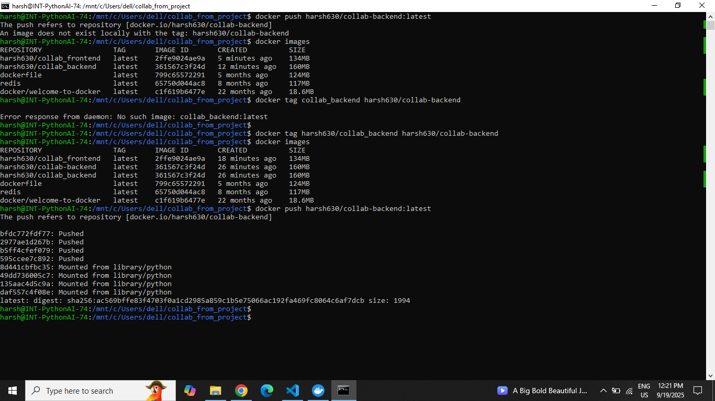

Push Frontend Image
- Run:
- docker push harsh630/collab-frontend:latest
- 📸 Screenshot: Successful push output.
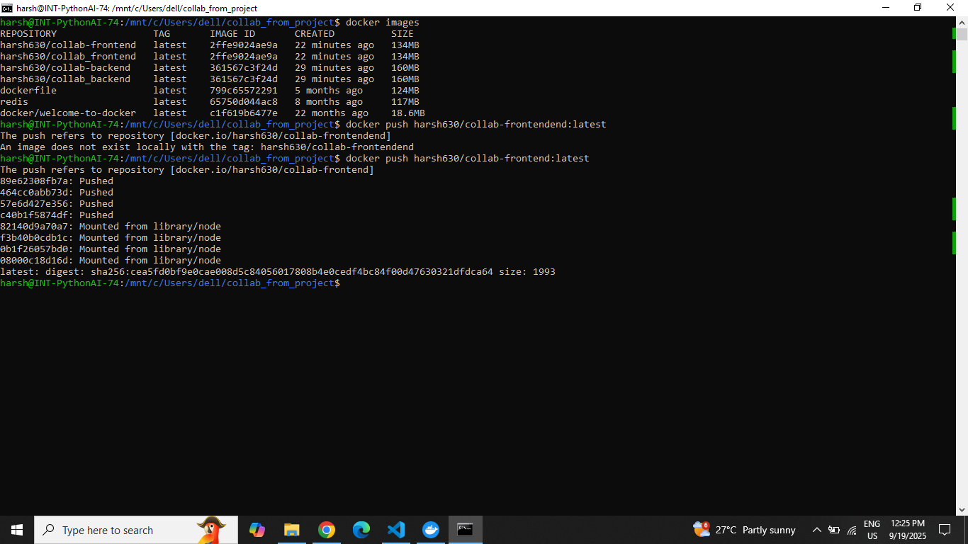

GitHub Repo Page
- 📸 Screenshot: Your GitHub repo page with frontend, backend, and docker-compose.yml visible.
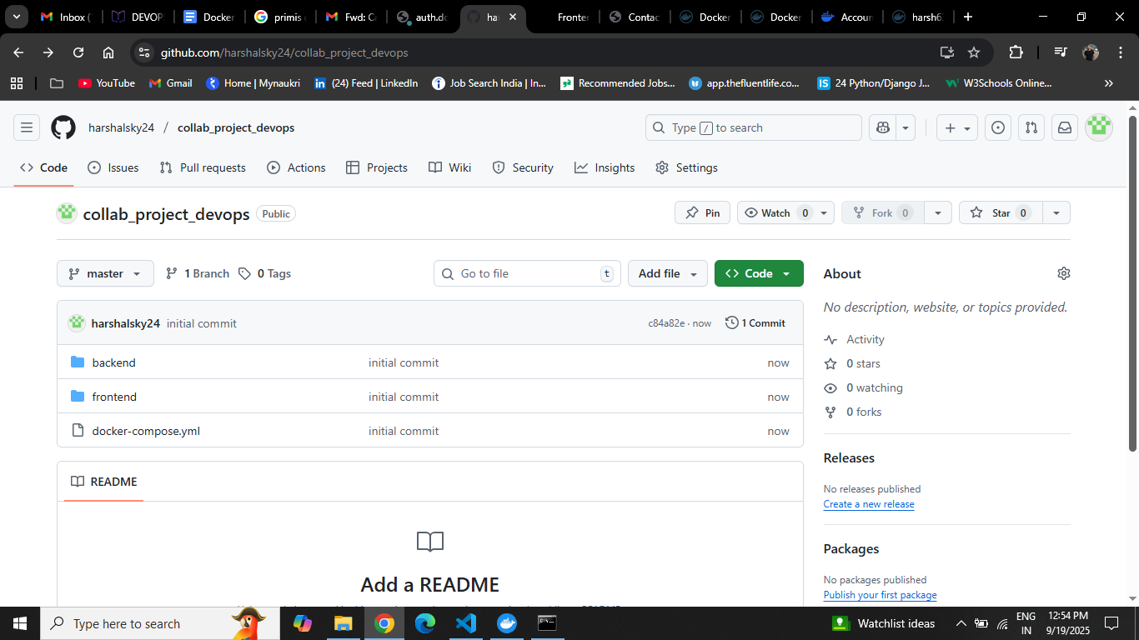

On Docker Hub
- 📸 Screenshot: The two repositories (collab-backend and collab-frontend) listed.
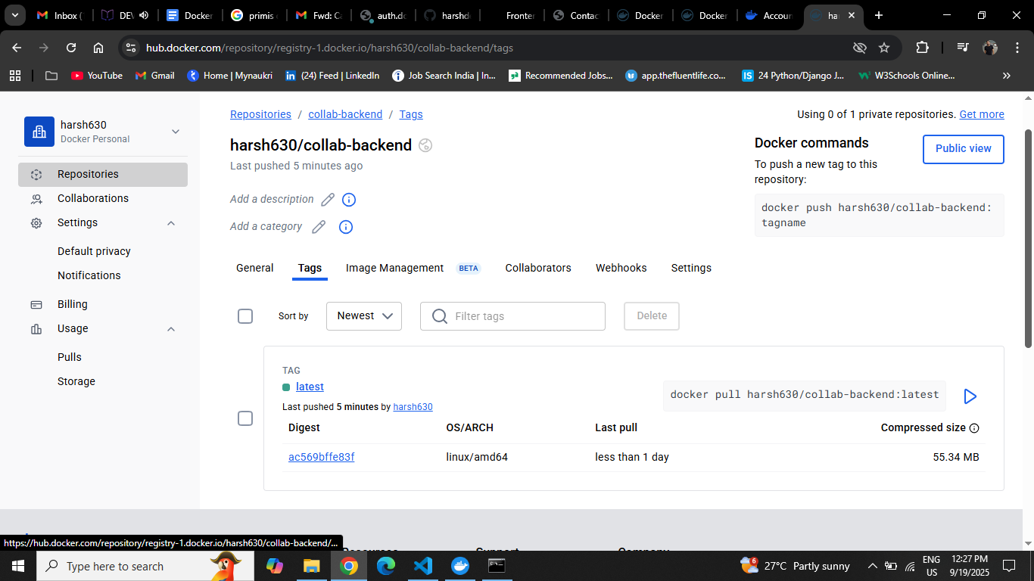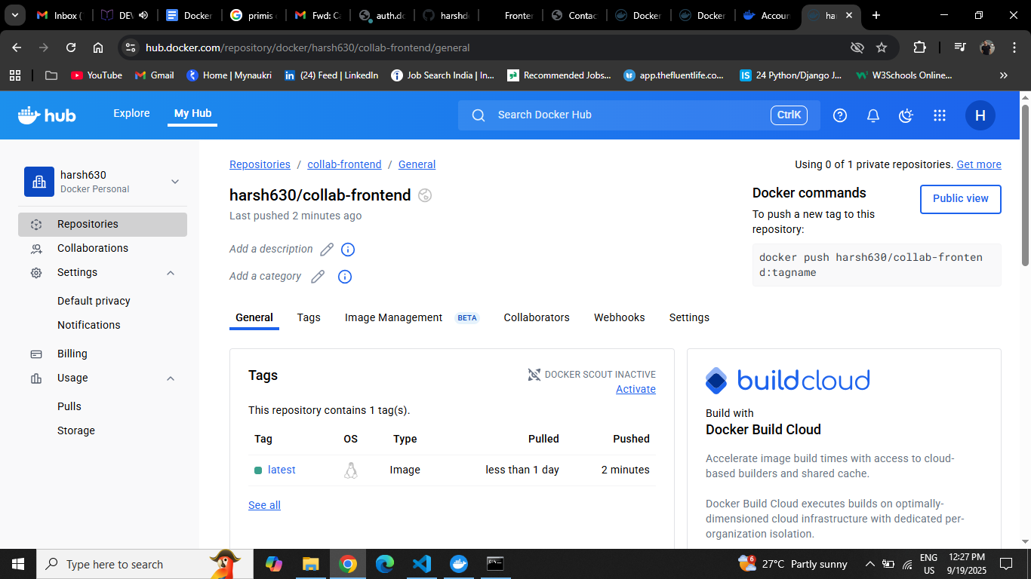

docker-compose up –build
